Project Design Phase-II
Data Flow Diagram & User Stories

Date | 08-03-2026
Team ID | SWTID-2026-1942
Project Name | Product inventory management
Maximum Marks | 4 Marks

Data Flow Diagrams:
A Data Flow Diagram (DFD) is a powerful way to visually represent how information moves through your system. It highlights the sources of data, the processes that transform it, the flows between components, and the storage locations. A neat and clear DFD ensures stakeholders can quickly understand the system requirements graphically.
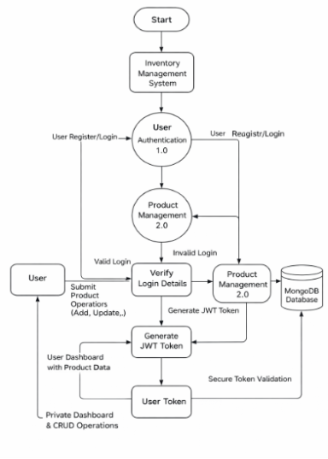
User Stories
To list all the user stories for the product.
User Type | User Story Number | User Story / Task | API Endpoint | Method | Authentication Required | Acceptance Criteria | Priority | Release
Customer (Web User) | USN-1 | As a user, I can register an account | /api/auth/register | POST | No | User registers using email & password. Password is hashed and stored securely. API returns success message with status code 201. | High | Sprint-1
Customer (Web User) | USN-2 | As a user, I can log in securely using JWT authentication | /api/auth/login | POST | No | User logs in with valid credentials. System verifies password and returns JWT token. Status code 200 returned. | High | Sprint-1
Customer (Web User) | USN-3 | As a user, I can add new products to my inventory | /api/products | POST | Yes | Authenticated user can add product with name, description, price, and quantity. Product stored with userId. | High | Sprint-1
Customer (Web User) | USN-4 | As a user, I can view all my products in a dashboard | /api/products | GET | Yes | API returns all products belonging to logged-in user. Returns status code 200 with product list. | High | Sprint-1
Customer (Web User) | USN-5 | As a user, I can update product details like price and quantity | /api/products/:id | PUT | Yes | Authenticated user can update product price or quantity. Changes saved in database. | Medium | Sprint-2
Customer (Web User) | USN-6 | As a user, I can delete products from my inventory | /api/products/:id | DELETE | Yes | Product is removed from database and no longer appears in dashboard. | Medium | Sprint-2
Customer (Web User) | USN-7 | As a user, I can search products by name | /api/products?name=keyword | GET | Yes | API filters products based on name query parameter and returns matching results. | Low | Sprint-2
Customer (Web User) | USN-8 | As a user, I can sort products by price, quantity, or name | /api/products?sort=price | GET | Yes | Products are returned sorted based on selected field (price, quantity, or name). | Low | Sprint-3
Customer (Web User) | USN-9 | As a user, I can view product details | /api/products/:id | GET | Yes | Clicking a product fetches full product details including description, price, and quantity. | Medium | Sprint-3
Customer (Web User) | USN-10 | As a user, I can log out securely | /api/auth/logout | POST | Yes | JWT token is cleared or invalidated and user is redirected to login page. | High | Sprint-1
Customer (Web User) | USN-11 | As a user, I receive error messages for invalid actions | All APIs | - | Depends | System returns proper error messages (400, 401, 404, 500) for invalid inputs or actions. | Medium | Sprint-2

